Practical(6.1.2)
Aim: Write a Python program to calculate the factorial of a number n using loops.

Algorithm:
- Start.
- Read a number n from the user.
- If n < 0→ Print "Factorial not defined for negative numbers” → Stop
- Set fact = 1
- Set i = 1
- Repeat while i ≤ n → fact = fact × i → i = i + 1
- Print "Factorial of n is fact"
- Stop.

FLOWCHART
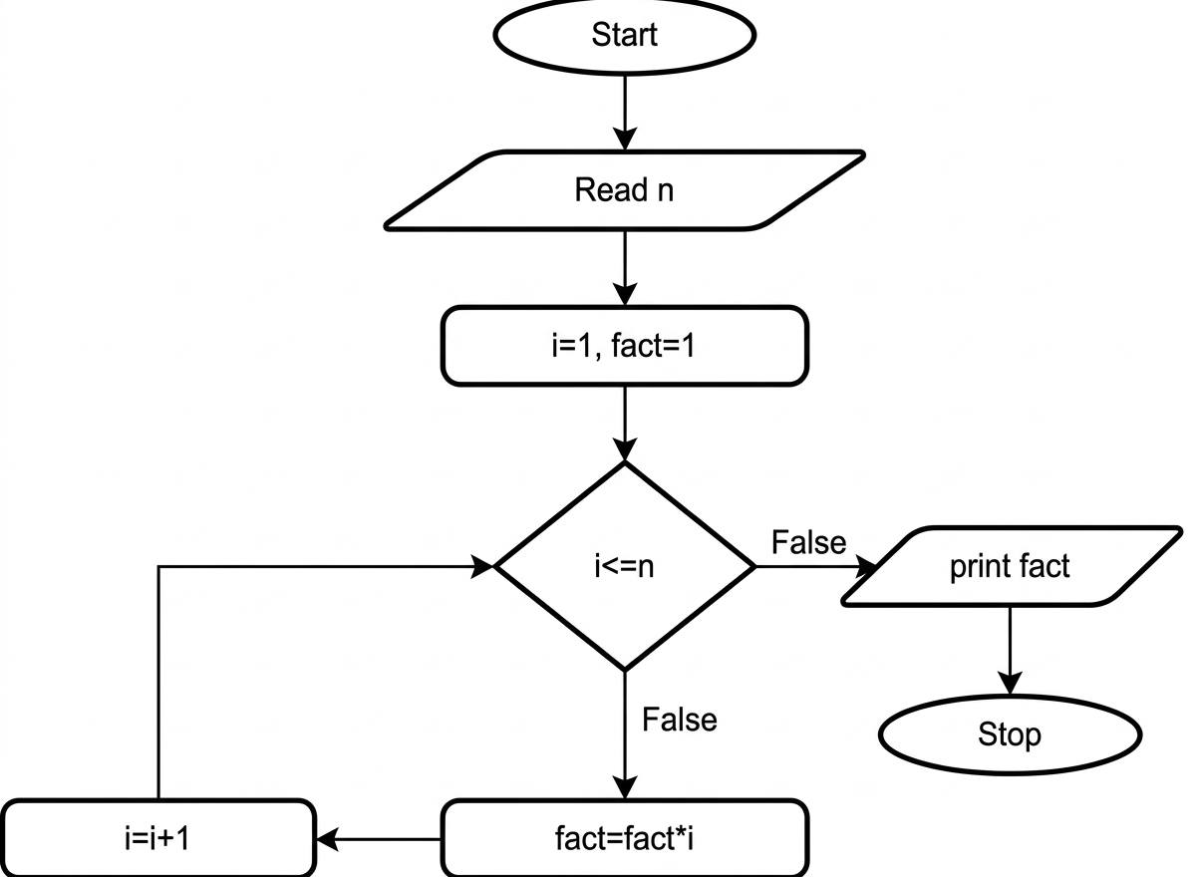

EXECUTION
